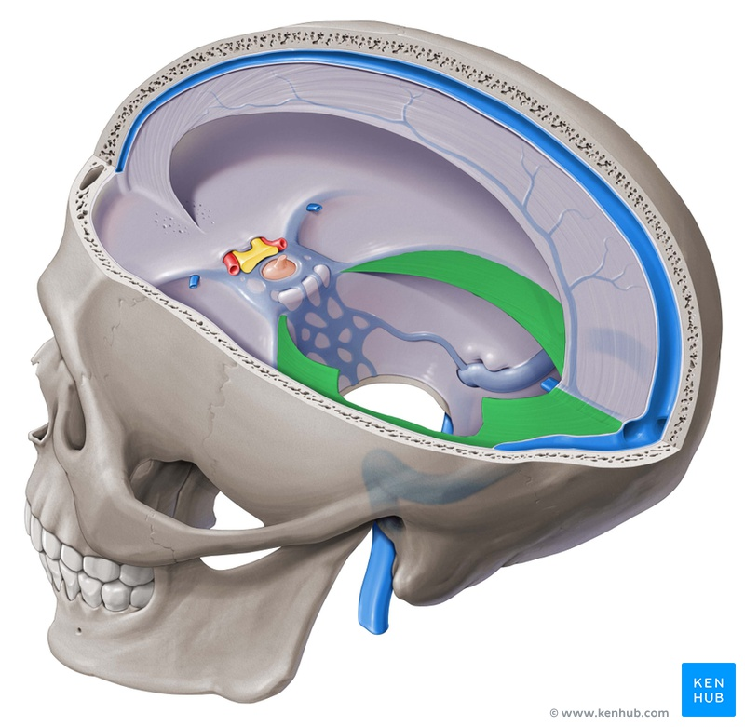
Visceral Manipulation Middle Jiao
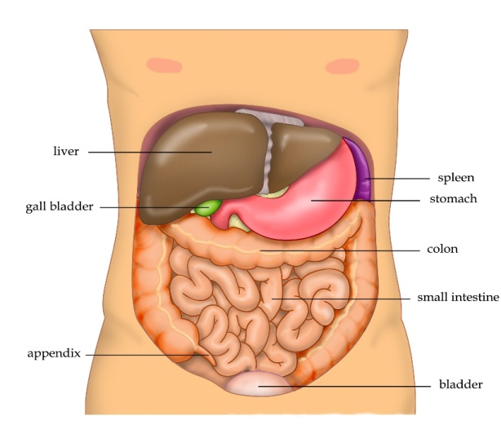
In MIDDLE JIAO Level 2 learn principles of Visceral Manipulation. Feel organs and their ligaments and fascia. Drain the liver and gallbladder. Assess the root of the mesentery. Release vagal tension and open arterial pulses of organs. You will deepen your experience with the viscera and gain useful skills.

Acupuncture CEUs
Learn Visceral Manipulation strategies from a long-time practitioner while earning 3 CEUs. CE Provider 1202. CAB course Category 1. L.Ac. lic. AC 5546. These half day courses are designed to improve anatomical precision and expand your ability to feel and connect to tissue.

Manual Skills Series

Level 1:

Palpation Basics
This 3.5 hour class is the prerequisite for all of the Level 2 courses. Repeating the class is recommended.
Course Dates:
Level 1: Palpation Basics
March 15, 2020 PM

Manual Skills Series

Level 2 Courses:
Focus and gain efficiency with each 3.5 hour module.
Course Name & Dates:
Middle Jiao March 15, 2020 PM

Course Location:

Pacific Center of Health

8555 Aero Drive, Ste. 107 San Diego 92123

Please park and enter at back of building

Save 10% - Take both classes offered on Mar. 15, 2020

Sunday, March 15, 2020 Manual Skills Series:

Level 1 Palpation Basics: 9:00 am - 12:30 pm
Level 2 Middle Jiao: 1:00 pm - 4:30 pm

Testimonials
-I am still amazed how releasing a nerve clears a chronically inflamed joint. The thickened scar tissue just melts.
-Even though there was so much detail, I was able to absorb it. I was so surprised when I first felt a nerve. It just lit up!
Adrian Bean L.Ac. (Lic. No AC5546, CE Provider No. 1202) has been mentoring students for over 20 years. He practices at Pacific Center of Health in San Diego and is Certified in Neural Manipulation by the Barral Institute. Please pre-register and arrange payment prior to class by contacting Pacific Center of Health at (619)542-0884 / F: (619)542-0949 or via email Lexi@pacificcenterofhealth.com.
Fees & Refund Information:
Cost: $75 per course. Class fees are fully refundable when requested 30+ days prior to the scheduled date. Refunds requested within 15-29 days prior will receive a 50% refund. No refunds given for requests 14 days or less prior to the class or for no shows.
These courses are approved or pending approval by the California Acupuncture Board, Provider Number 1202,
for 3.0 hours of continuing education.

