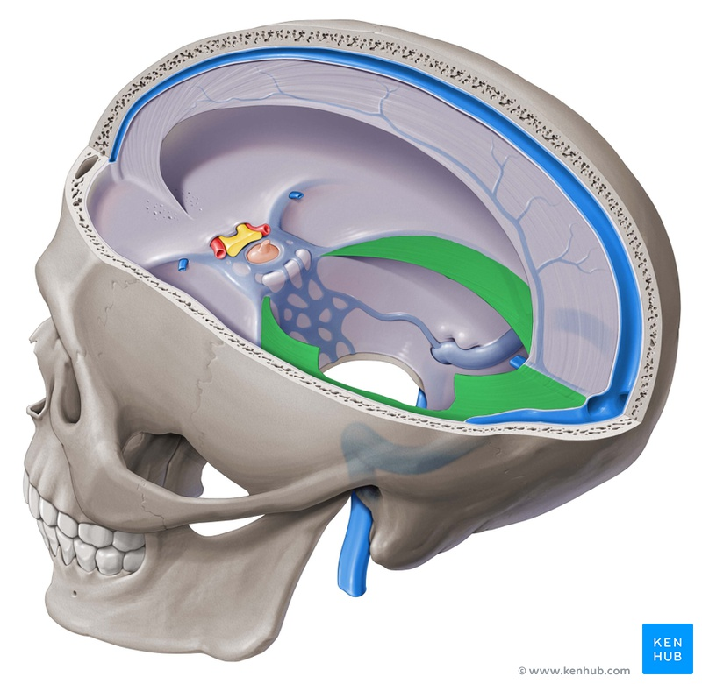
Visceral and Cranial Self Care

Self Care Basics
Learn to release you nervous system and witness your body breathe. Explore Visceral and Cranial Manipulation strategies from a long-time practitioner. These half day courses are designed to improve anatomical precision and expand your ability to feel and connect to your own tissues.

Level 1 Palpation
This 3.5 hour class is the prerequisite for all of the Level 2 courses. Repeating is recommended.
Level 1 Manual Palpation
March 15, 2020
9:00am – 12:30pm

Level 2 Classes
Deepen your skills! Middle Jiao covers techniques to treat organs, nerves, arteries and fasica of the abdomen.
Middle Jiao
March 15 , 2020
1:00 pm – 4:30pm

*You can take Level 1 in the morning, and Level 2 in the afternoon on March 15th and save 10%.

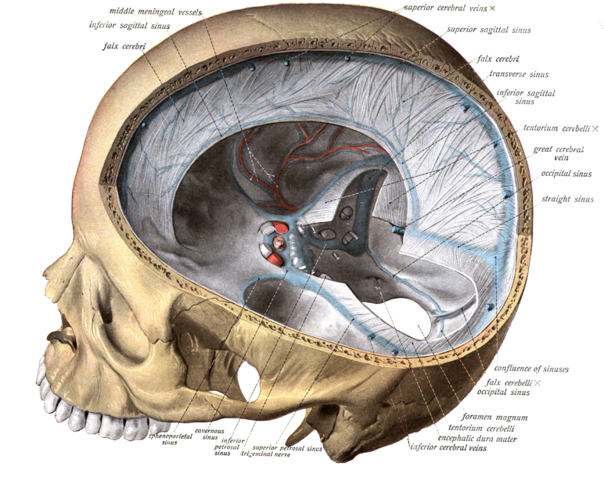
Treat Yourself! Learn principles of Visceral Manipulation and Cranial Osteopathy and apply techniques to your own body! Suited to practitioners and patients, anyone who wants to improve their own health. Feel your tissues and learn how to help them release. Sharpen your meditation skill. Attain deep relaxation. Discover your Intrinsic Breath.

Sunday, March 8, 2020

9:00am - 12:30pm

Pacific Center of Health

8555 Aero Drive San Diego 92123

Please park and enter at the back of the building

Testimonials
-I am still amazed how releasing a nerve clears a chronically inflamed joint. The thickened scar tissue just melts.
-Even though there was so much detail, I was able to absorb it. I was so surprised when I first felt a nerve. It just lit up!
Adrian Bean L.Ac. has been mentoring students for over 20 years and is Certified in Neural Manipulation by the Barral Institute. Please Pre-Register and arrange payment prior to class. All classes are $75. Call Pacific Center of Health at (619)542-0884 or email us frontdesk@pacificcenterofhealth.com .

